Google Fusion Table API V1 Wrapper

Abstract
In order to use the API Wrapper provided by SymSoft Solutions, users may need to provide a few parameters. If the fusion table is publically shared, API Key is required. If your table is private, users will need client email address and private key. For SQL query, encrypted table ID is required. This document describes how to acquire the information users need to make use of Fusion table wrapper API.

Procedure
- In order to use Google Fusion table APIs, the service must be turned on. Go to Google API Console (https://code.google.com/apis/console/)
- If this is the first visit, you may see this screen. Click “Create project…”
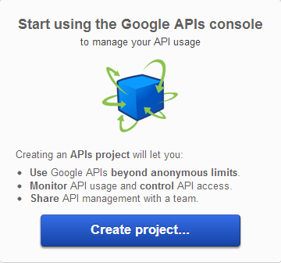
- Turn on “Fusion Table API”

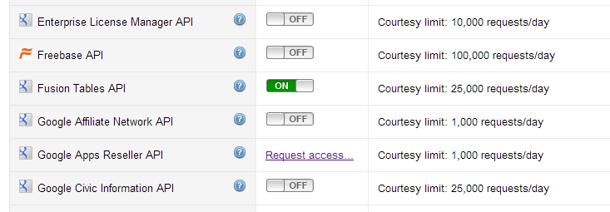

- Open “API Access” tab.
- If the table is public and you only need read access (SELECT), you only need API key. API key can be obtained on this screen. (Green arrow)
- Otherwise, click “Create an OAuth 2.0 client ID…” (Orange arrow)

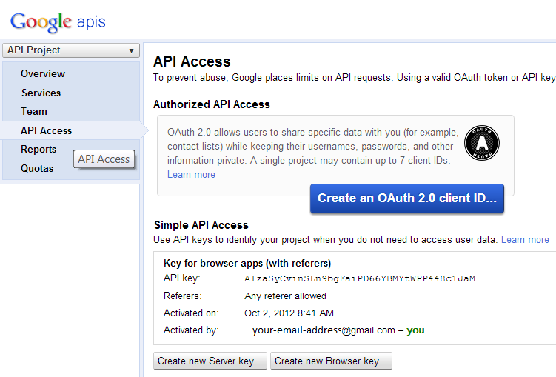
- Enter the product name and logo address. Click “Next”.
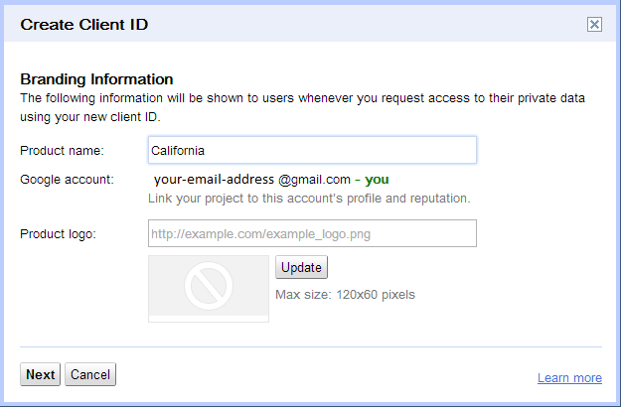
- Select “Service Account” and click “Create client ID”
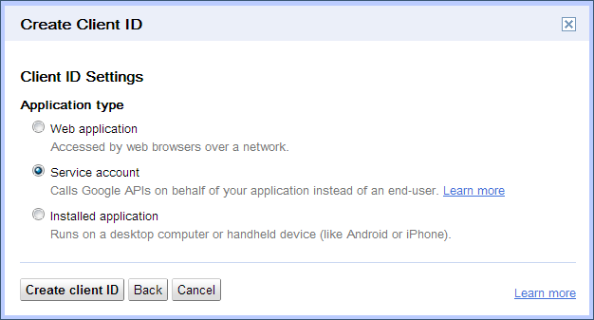
- Click Download private key
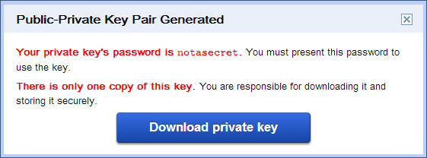
- Move the file to the appropriate location where the app can access. Make sure only your app can read this file. This file should not be public. The path to this file is required for wrapper API parameter.
- On the API Console, the service account information will be shown as below. E-mail address under the service account is required for wrapper API. NOT your email address.
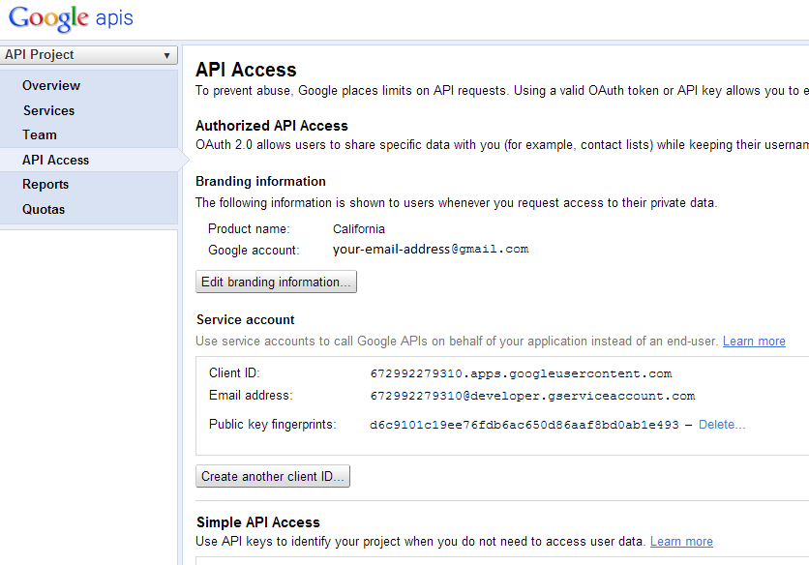
- In order for you application to have access the Fusion table via API, the email address you obtained in previous stem must have edit privilege on your table. Go to your fusion table and click button. And you will see the pop up screen as below. Enter the email address in the textbox at the bottom and click “Share & Save”
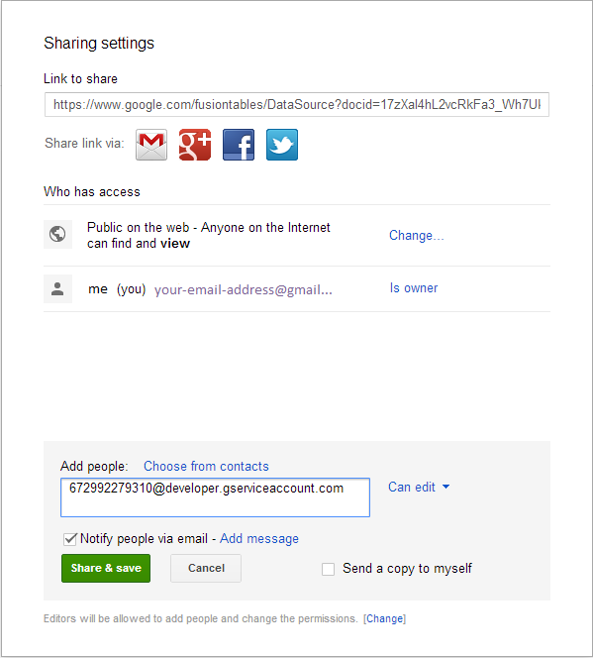
- Now you can access your fusion table using API wrappers.
- With new Google APIs, Encrypted table ID is required for SQL query. In order to find the table ID, click File > About This Table.
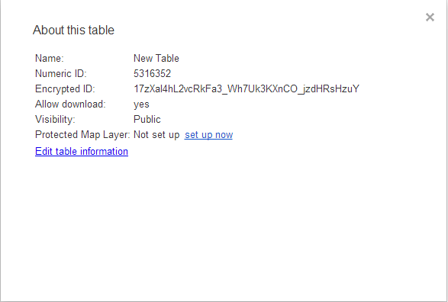
- More information about SQL query can be found at: https://developers.google.com/fusiontables/docs/v1/sql-reference

