This is a brief tutorial on how to eliminate “suggested videos” that show on the video screen after a video has played. This only works for Youtube videos embedded into sites outside of Youtube.
By default, your video screen would look something like this after your video has finished playing. The suggested videos populate the screen.
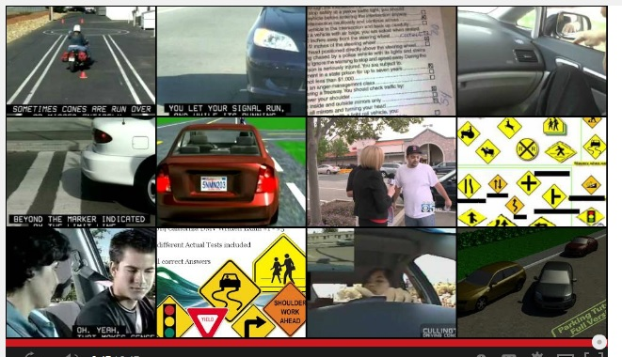
To prevent this from happening on the embedded video on your own website or any non-Youtube site:
1. Go to your video on Youtube and click “Share.”
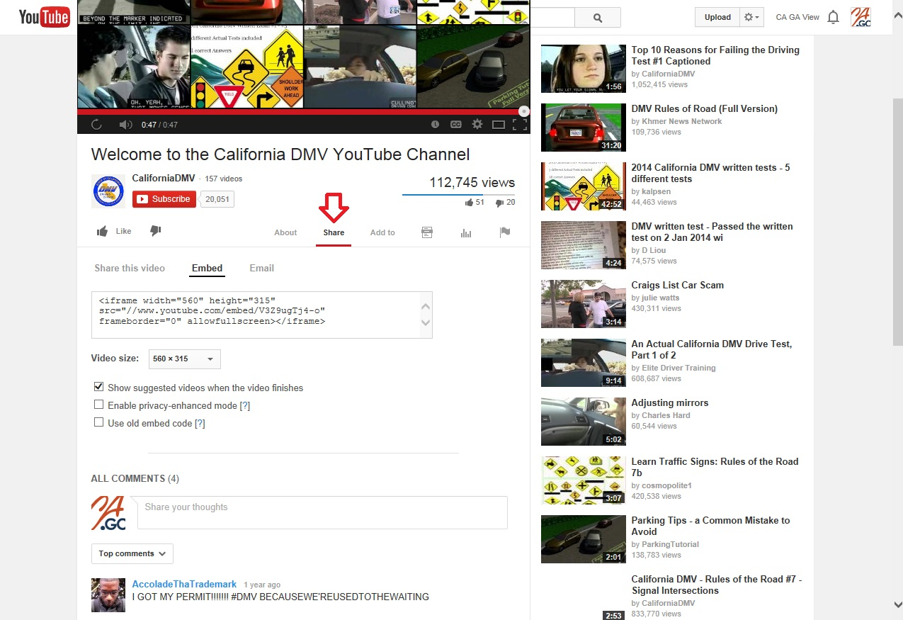

2. Click “Embed.”
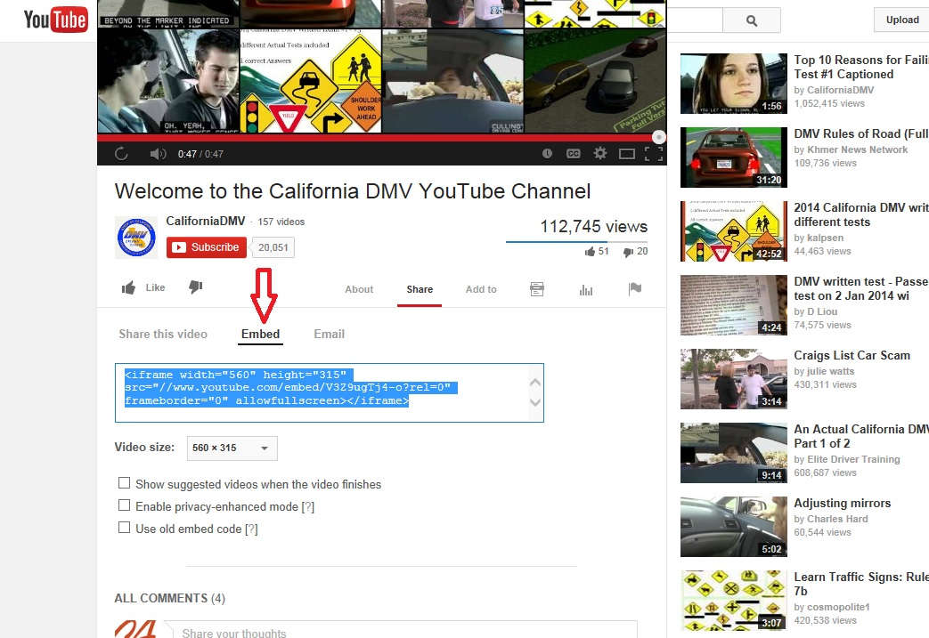
3. Uncheck the box that says “Show suggested videos when the video finishes.”
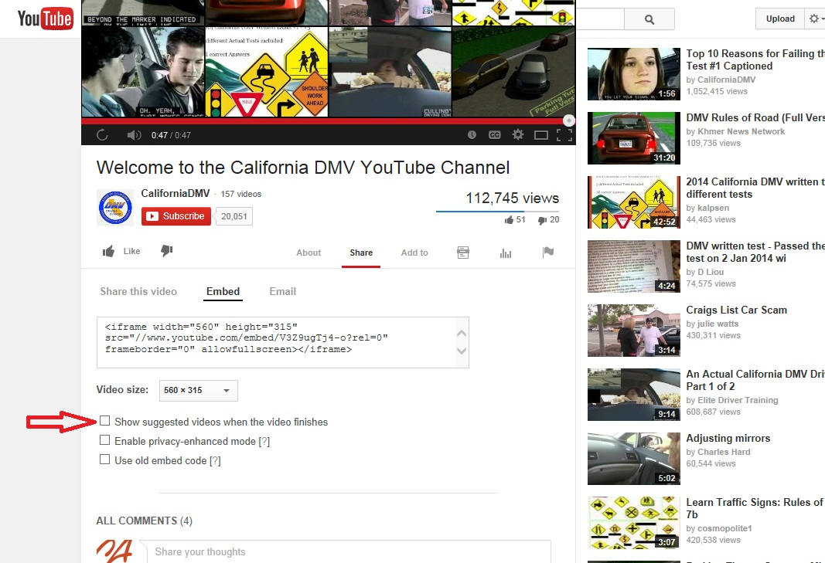
Now when you embed this video into sites outside of Youtube, suggested videos will no longer show after the video finishes playing on the non-Youtube site.

